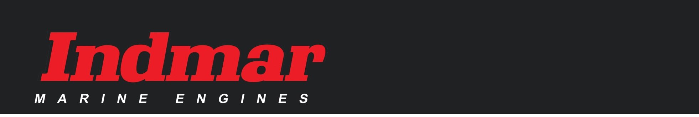
INDMAR MARINE ENGINES CONTACTS

INFORMATION
Sonya Young syoung@indmar.com 901-353-9930 ext. 1000
ACCOUNTING
Accounts Receivable ar@indmar.com
Sarah Reed sreed@indmar.com 901-353-9930 ext. 1210

CUSTOMER SERVICE & PARTS SALES
Customer Service customerservice@indmar.com 800-970-3744
901-260-0456
Joe Cutberth jcutberth@indmar.com 901-353-9930 ext. 1530

FORD PRODUCTS
Jim Hardy jhardy@indmar.com 901-353-9930 ext. 1480
Allen McDaniel amcdaniel@indmar.com 901-353-9930 ext. 1360

GM LEGACY PRODUCTS
John Todd (JT) jtodd@indmar.com 901-353-9930 ext. 1250
Al Wendel awendel@indmar.com 901-353-9930 ext. 1200

WARRANTY
General Warranty warranty@indmar.com
Warranty Claims jperdue@indmar.com 901-353-9930 ext. 1310
Warranty Reg. jperdue@indmar.com 901-353-9930 ext. 1310
Warranty Transfers jperdue@indmar.com 901-353-9930 ext. 1310

DEALER ACCOUNTS
Dealer Accounts/Locator syoung@indmar.com 901-353-9930 ext. 1000

WEBSITE HELP
Web Support webhelp@indmar.com 901-353-9930 ext. 1820

SERVICE TRAINING
Jenni Perdue indmaru@indmar.com 901-353-9930 ext. 1310

MARKETING
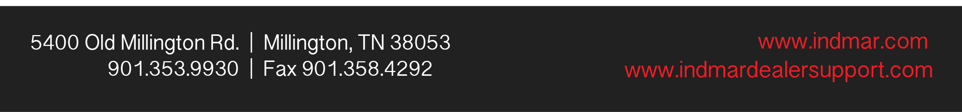
Natalie Carrera ncarrera@indmar.com

